INTEGRATIVE COURSE IN PSYCHOLOGY (ICOPSYCH)

ANALYSIS ON THE RESULT OF POST-TEST EXAMINATION IN INDUSTRIAL PSYCHOLOGY
MAY 24, 2025

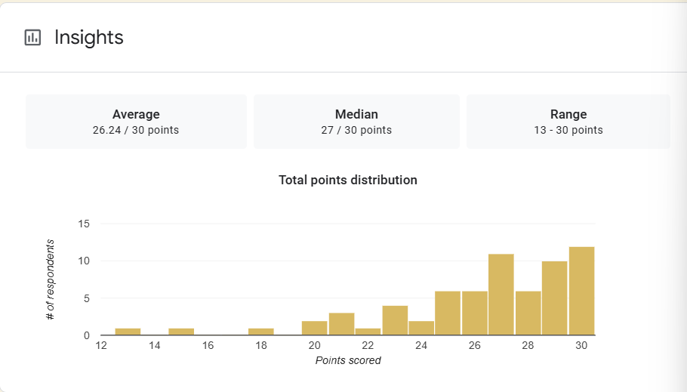

1. Mean Score: The mean score of 26.24 indicates very high average performance. This translates to approximately 87.5%, suggesting that the majority of test-takers have a strong grasp of the content assessed.

2. Median Score: The median score is 27, slightly higher than the mean. At least half of the test-takers scored 27 or higher, indicating that high performance was common.

3. Range: The range of 17 points shows some variability in performance levels, from moderately low (13) to perfect scores (30). The presence of both low and high extremes suggests diversity in ability or preparation among the participants, though the high central tendency dominates.

Interpretation Summary:

-The test results show excellent overall performance, with most participants scoring near the top.

-The broad range (13–30) reflects some variation in achievement, but this does not significantly affect the strong central tendency.

-These results suggest the test was well understood by most, with potential room to support a few individuals who may have struggled.

RATIONALIZATION:

DIFFICULT QUESTIONS:

